AI Use Declaration Form
Course: Introduction to Artificial Intelligence
Lab Title: Lab 3
Student Name: Chrishelle Wiafe
Student ID: 85942028
GitHub Repository Link:
Date Submitted: 28/07/26

1. AI Use Summary
Question | Student Response
Did you use any AI tool for this lab? | Yes please
Estimated percentage of the work influenced by AI | 24%
Did you attach evidence of AI use where applicable? | yes

2. Details of AI Use
Complete the table below for each AI tool used. Add more rows where necessary.
Name of AI Tool Used | Purpose for Using the Tool | Prompt or Instruction Given to the Tool | Part(s) of the Work Influenced by the Tool | How I Verified, Edited, or Improved the AI Output
ChatGPT | Understanding and implementing concepts | what is the purpose of the tensor and then wrapping in a DataLoader | Tensor and DataLoader wrapping
ChatGpt | Correction of errors | TypeError: can't convert np.ndarray of type numpy.object_. The only supported types are: float64, float32, float16, complex64, complex128, int64, int32, int16, int8, uint64, uint32, uint16, uint8, and bo | Part 2.1

3. Attachment of AI Output Evidence
Where required, attach evidence of AI use. Tick all that apply. Add more rows where necessary.
Evidence Type | Attached? (Yes, No, N/A) | File Name
AI-generated draft | yes | 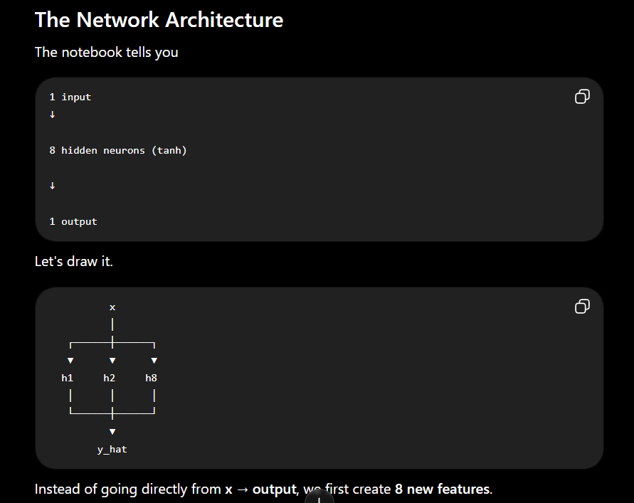
Prompt history
Screenshot of AI interaction | yes | 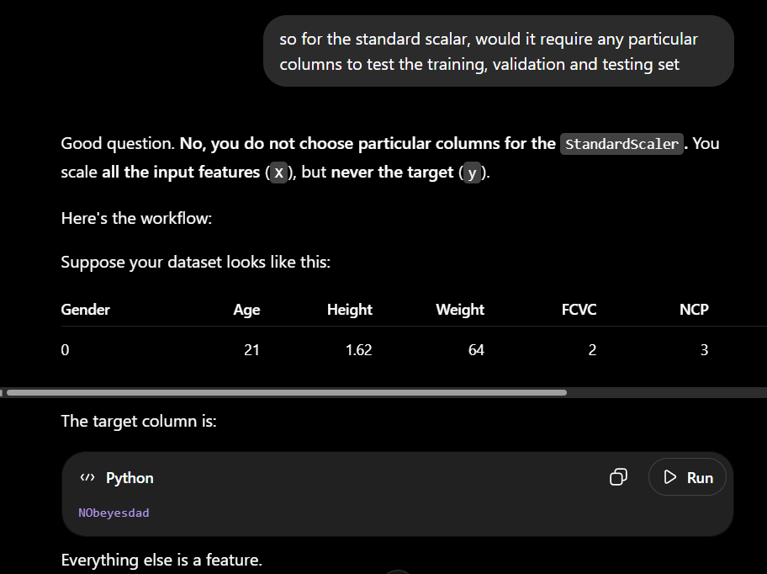
Exported AI conversation
AI-generated code snippet |  | 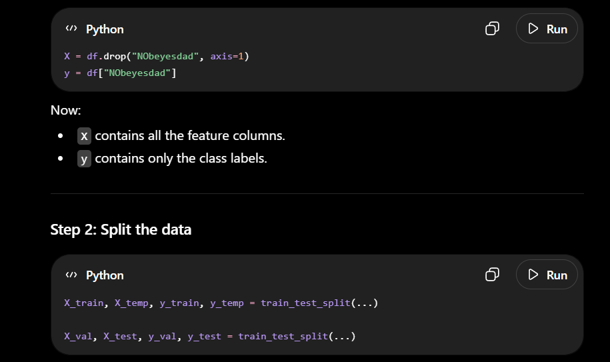
Revised version showing student input |  | 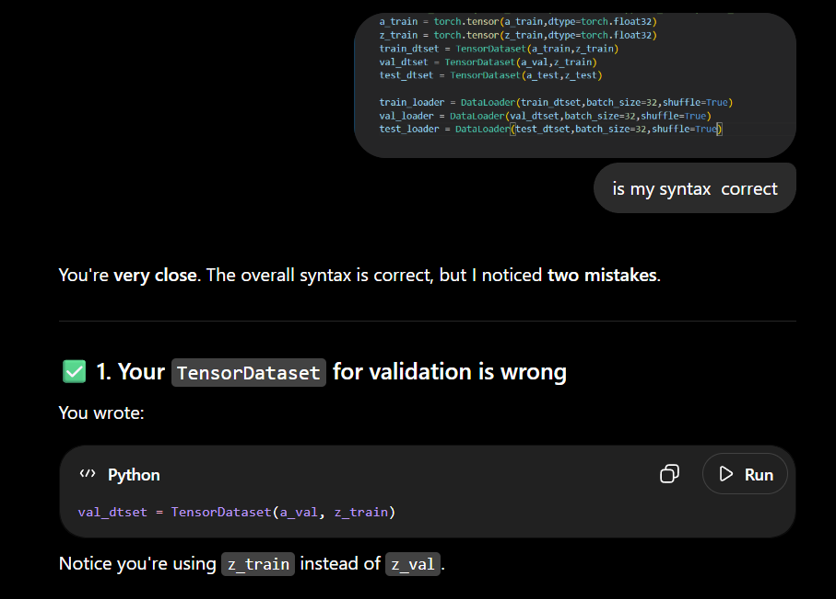

4. Student Declaration
I declare that:
Declaration Statement | Response (Yes/No)
The submitted work is my own work. | yes
Any use of AI tools has been clearly declared in this form. | yes
The prompts, instructions, and AI-generated outputs have been disclosed where applicable. | yes
I reviewed, tested, edited, and improved any AI-generated content before submission. | yes
My AI usage does not exceed 25% of the entire work. | yes
I understand that undeclared or excessive AI use may be treated as academic misconduct. | no

Student Signature: C.W
Date: 28/07/2026

